The Brocken Spectre – A Rare, Heavenly Appearance

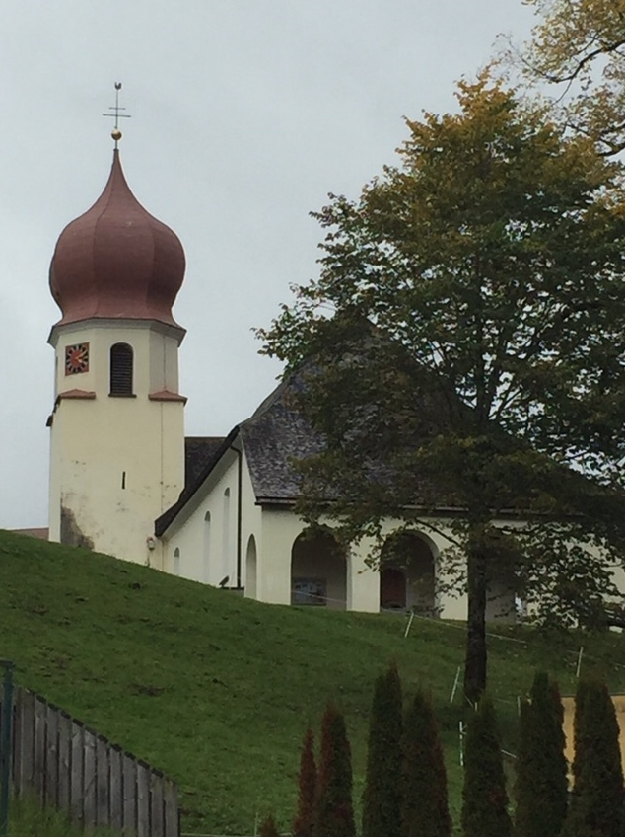
1st October 2017 . On this day, I decided I would climb the 2017m high Kellaspitze, which overlooks the small hamlet of Marul in the Grosseswalsertal area of the Bregenzerwald in Austria. I had climbed this mountain numerous times before in all weather seasons and conditions including a 7 hour epic many years ago in winter, when 1m of fresh snow made the going get tough and the tough get going, especially during the scramble up the north face !! But now, apart from fog in places, the conditions were snow free and I was looking forward to a pleasant ascent with sun and wonderful, panoramic views at the top. Little did I know what was in store for me later.

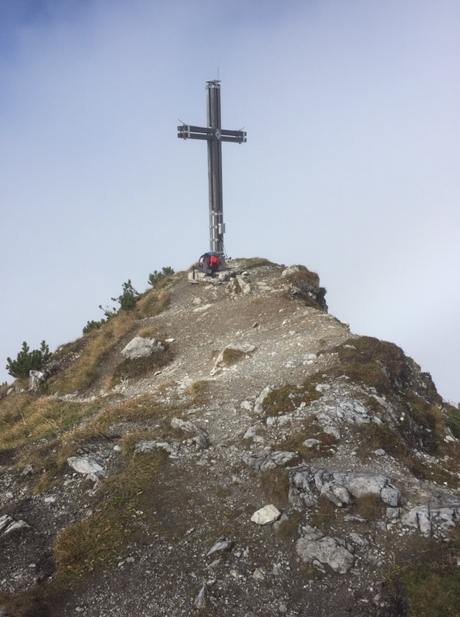
After about 3 hours, I reached the final fog free summit and made my way up
to the summit cross. Apart from three people I had passed coming down from just below the summit, there was nobody else on the mountain and I could enjoy the peace, quiet and solitude of the beautiful Vorarlberg mountains.

The views were spectacular and it was eerie to see the summit peeking through the fog into the wonderful world of blue sky, sun and breathtaking mountains. After taking a few photos, I sat down at the cross and had a sandwich and a cup of hot tea or two. I then got up and peered down the north side of the mountain into the void which was full of damp fog making it impossible to see anything at all.
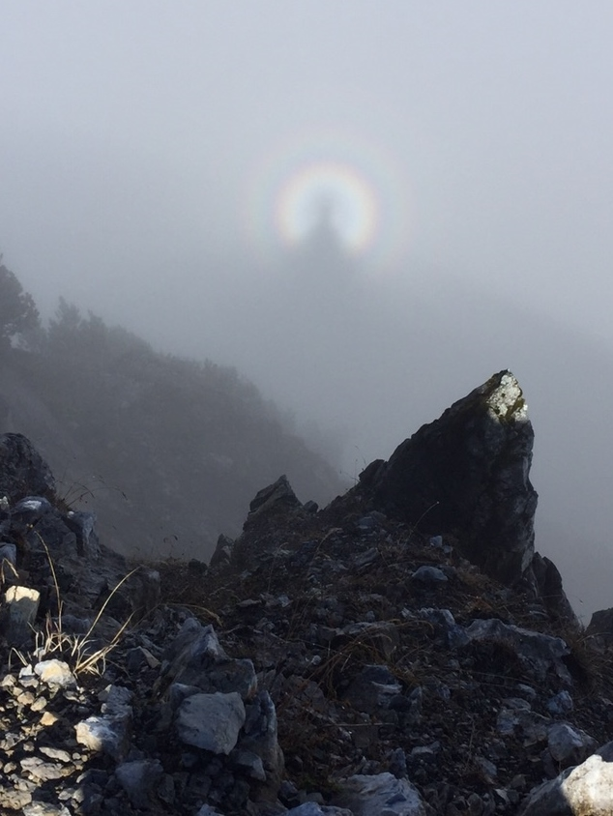
And then, all of a sudden, I couldn’t believe my eyes ….. a series of circular concentric rainbows appeared with a head in the middle with wing like formations on either side !! At first, I thought I was hallucinating due to the thinner air at 2017m but then I realised that it was real what I was looking at – so amazing, incredible, beautiful and out of this world. I had never seen anything like it before. I quickly took some photos and a video to document the evidence before it disappeared after about 2 minutes, so that people wouldn’t think I was going crazy when I told them about it afterwards !!

I wondered to myself what on Earth it could it be and how come I had been privileged to be the only one to see it. I was on an emotional high and I thought that maybe my mum and dad were trying to get in touch with me from above ? I sat down again at the cross to try to take it all in.

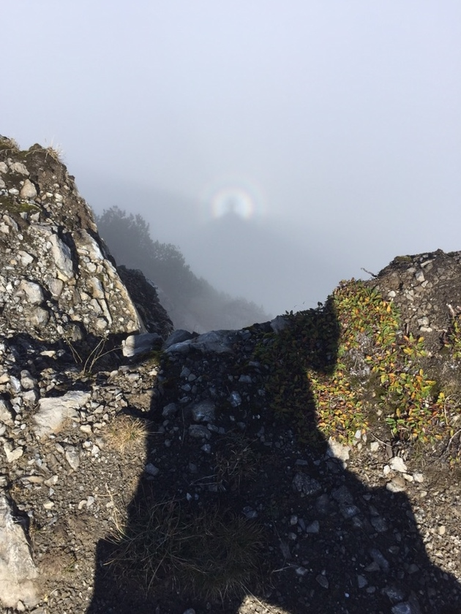
I was so curious that a few minutes later, I got up again to see if the heavenly apparition had appeared again and at that very moment it did indeed to my astonishment and joy ☺. This time, it only lasted for about a minute and I was very quick to take a few final snaps of this splendid “unknown” phenomenon. I couldn’t believe my luck that I had seen it twice and now I was convinced that my parents had made contact with me as guardian angels, in order to send me a message – but what was the message ?

This remarkable vision really had made my day and I couldn’t stop thinking about it all the way back down to the car. I didn’t even notice the exposed Klettersteig parts because I was so intoxicated by this experience. When I arrived back at the car, I tried to look on the internet to find an explanation for what I had seen, but unfortunately, the network connection was poor and
I had to wait until I got home to my WLAN.

At home , I discovered that I had seen a “Brocken Spectre”, which was first sighted in 1780 by the german Lutheran Johann Silberschlag, a natural scientist and theologian, on the 1141m high Brocken summit in the Harz mountains in northern Germany. It gets the second part of its name from the English noun “spectre”which means a ghostly apparition. It is very rare for a mountaineer to see a Brocken Spectre in the Alps and that added even more to my belief that my parents had made contact with me, even though there is a “physical” explanation behind the phenomenon. When the sun is behind you and you look down into a damp, foggy void, you see your head surrounded by circular rainbows due to refraction and reflection by the raindrops in the fog. The wing formations on either side come from your brain’s enquiring mind and makes you truly believe that you have seen an angel apparition !!

After doing some more research, I discovered that there is a legend associated with the Brocken Spectre. When a mountaineer sees one, he dies the next day !! Obviously, that did not happen, but unfortunately three days later my lovely Audi A4 Avant died a sudden death with complete motor damage on my way to school ☹. I was unhappy and sad for a while, but then saw that in every cloud there is a silver lining. Within 24 hours, I had sold my Audi, paid off the bank loan and with all of the money I got back from the insurance and road tax, and saved because I didn’t have to buy winter tyres, have an MOT or repairs, I was able to start up my music again. I bought myself a Fender Stratocaster, two Marshall amplifiers (for electric and acoustic guitars) and a microphone, and soon afterwards, I began composing, recording, mixing and producing songs. And in 2019, I released 2 albums “Return” and “The Soft Songs” and 3 singles “Our Future”, “Let’s Go” and “How The Heart Feels” under the band name Aztec Warrior.
A third album is on the way and will be released in 2020.

Who knows, maybe one day I’ll have a hit song and become famous, and all because I saw the Brocken Spectre. And of course it was only a concidence that the year was 2017 and the Kellaspitze was 2017m high … or was there another explanation ?
